# DBMS LAB

# LIST OF EXPERIMENTS

# 1. Create a database table, add constraints (primary key, unique, check, Not null), insert rows, update and delete rows using SQL DDL and DML commands.

# 2. Create a set of tables, add foreign key constraints and incorporate referential integrity.

# 3. Query the database tables using different ‘where’ clause conditions and also implement aggregate functions.

# 4. Query the database tables and explore sub queries and simple join operations.

# 5. Query the database tables and explore natural, equi and outer joins.

# 6. Write user defined functions and stored procedures in SQL.

# 7. Execute complex transactions and realize DCL and TCL commands.

# 8. Write SQL Triggers for insert, delete, and update operations in a database table.

# 9. Create View and index for database tables with a large number of records.

# 10. Create an XML database and validate it using XML schema.

# 11. Create Document, column and graph based data using NOSQL database tools.

# 12. Develop a simple GUI based database application and incorporate all the above mentioned features 13. Case Study using any of the real life database applications from the following list

# a) Inventory Management for a EMart Grocery Shop

# b) Society Financial Management

# c) Cop Friendly App – Eseva

# d) Property Management – eMall

# e) Star Small and Medium Banking and Finance

# CONTENTS

|  |  |
| --- | --- |
| **EX.NO** |  |
| 1. | Create a database table, add constraints (primary key, unique, check, Not null), insert rows, update and delete rows using SQL DDL and DML commands. |
| 2. | Create a set of tables, add foreign key constraints and incorporate referential integrity. |
| 3. | Query the database tables using different ‘where’ clause conditions and also implement aggregate functions. |
| 4. | Query the database tables and explore sub queries and simple join operations. |
| 5. | Query the database tables and explore natural, equi and outer joins. |
| 6. | Write user defined functions and stored procedures in SQL. |
| 7. | Execute complex transactions and realize DCL and TCL commands. |
| 8. | Write SQL Triggers for insert, delete, and update operations in a database table. |
| 9. | Create View and index for database tables with a large number of records. |
| 10. | Create an XML database and validate it using XML schema. |
| 11. | Create Document, column and graph based data using NOSQL database tools. |
| 12. | Develop a simple GUI based database application and incorporate all the abovementioned features |
| 13. | Case Study using any of the real life database applications from the following lista) Inventory Management for a EMart Grocery Shopb) Society Financial Managementc) Cop Friendly App – Esevad) Property Management – eMalle) Star Small and Medium Banking and Finance |

**Data Definition Commands, Data Manipulation Commands and Constraints**

**EX.No :1**

**AIM:**

# To create a database and how to perform the operations and add constraints.

**ALGORITHM:**

Step 1: Create a table using sql query

Step 2: Enter the input in the created table

Step 3: To retrieve a data from table use select command

Step 4: Add constraints primary key, unique, check, Notnull

Step 5: The output will be displayed based on the query.

**PROGRAM:**

DDL (DATA DEFINITION LANGUAGE) COMMAND:

1. CREATE
2. ALTER
3. DROP
4. TRUNCATE
5. COMMENT
6. RENAME
7. Creation of database and table:

mysql>create database db;

Query OK, 0 rows affected (0.14 sec) mysql>use db;

Database changed

1. Create the table:

SQL> CREATE TABLE STUDENT (SNO INT, NAME CHAR (11), POSITION VARCHAR(8));

Table created.

1. View the table structure: SQL> DESC EMP; Name Null? Type

EMPNO INT

ENAME CHAR(11) POSITION VARCHAR (8)

1. Alter the Table:

SQL>ALTER TABLE EMP MODIFY EMPNO INT;

Table altered.

SQL> DESC EMP;

Name Null? Type

EMPNO INT

ENAME CHAR(11)

POSITION VARCHAR(8)

SQL> ALTER TABLE STUDENT ADD( SALARY INT);

Table altered.

SQL> DESC EMP;

Name Null? Type

EMPNO INT

ENAME CHAR(11) POSITION VARCHAR(8)

SALARY INT

SQL>ALTER TABLE EMP ADD (DOB DATE, DOJ DATE);

Table altered.

1. Remove/Drop the Column:

SQL> ALTER TABLE EMP DROP COLUMN QUALIFICATION;

Table altered.

SQL> ALTER TABLE EMP DROP (DOB, QUALIFICATION);

Table altered

1. Rename the Table:

SQL> RENAME TABLE EMP TO EMPLOYEE;

1. Truncate the Table:

SQL> Truncate table EMPLOYEE;

1. Drop the table:

SQL> DROP TABLE EMPLOYEE;

DML (DATA MANIPULATION LANGUAGE)

* 1. SELECT
  2. INSERT
  3. DELETE
  4. UPDATE

1. Insert a record from an existing table:

SQL>INSERT INTO EMPLOYEE VALUES (101,'NAGARAJAN','LECTURER',15000);

1 row created.

SQL> INSERT INTO EMPLOYEE (EMPNO,ENAME,POSITION,SALARY) VALUES

(102,”KANNAN”,”PROFESSOR”,50000);

1. Display the records from employee. SQL> SELECT * FROM EMPLOYEE;

|  |  |  |  |
| --- | --- | --- | --- |
| EMPNO | ENAME | DESIGNATIN | SALARY |
|  |  |  |  |
| 101 | NAGARAJAN | LECTURER | 15000 |
| 102 | KANNAN | PROFESSOR | 50000 |

1. Update the Table:

SQL> UPDATE EMP SET SALARY=16000 WHERE EMPNO=101;

1 row updated.

1. Delete the row from Table:

SQL> DELETE EMP WHERE EMPNO=103;

1 row deleted.

1. Not NULL Constraint, Unique Constraint :

SQL> CREATE TABLE CUSTOMERS( ID INT NOT NULL, NAME VARCHAR (20)

NONULL, AGE INT NOT NULL UNIQUE, ADDRESS CHAR (25) , SALARY DECIMAL (18, 2),

PRIMARY KEY (ID) );

CUSTOMERS

ID

NAME

AGE

ADDRESS

Empty

SQL>INSERT INTO CUSTOMERS (ID,NAME,AGE,ADDRESS,SALARY)

VALUES (1, 'Ramesh', 32, 'Ahmedabad', 2000.00 );

SQL>INSERT INTO CUSTOMERS (ID,NAME,AGE,ADDRESS,SALARY) VALUES (2, 'Khilan', 25, 'Delhi', 1500.00 );

SQL>INSERT INTO CUSTOMERS (ID,NAME,AGE,ADDRESS,SALARY) VALUES (3, 'kaushik', 23, 'Kota', 2000.00 );

SQL>INSERT INTO CUSTOMERS (ID,NAME,AGE,ADDRESS,SALARY) VALUES (4, 'Chaitali', 25, 'Mumbai', 6500.00 );

CUSTOMERS

|  |  |  |  |
| --- | --- | --- | --- |
| ID | NAME | AGE | ADDRESS |
| 1 | Ramesh | 32 | Ahmedabad |
| 2 | Khilan | 25 | Delhi |
| 3 | kaushik | 23 | Kota |
| 4 | Chaitali | 25 | Mumbai |

1. Primary Key:

SQL>CREATE TABLE CUSTOMERS( ID INT NOT NULL, NAME VARCHAR (20) NOT NULL, AGE INT NOT NULL UNIQUE, ADDRESS CHAR (25) , SALARY DECIMAL (18, 2),PRIMARY KEY (ID) );

SQL>ALTER TABLE CUSTOMERS DROP PRIMARY KEY ;

ID | NAME | AGE | ADDRESS | SALARY |

+ + + + + +

| 1 | Ramesh | 32 | Ahmedabad | 2000.00 |

| 2 | Khilan | 25 | Delhi | 1500.00 |

| 3 | kaushik | 23 | Kota | 2000.00 |

| 4 | Chaitali | 25 | Mumbai | 6500.00 |

| 5 | Hardik | 27 | Bhopal | 8500.00 |

| 6 | Komal | 22 | MP | 4500.00 |

| 7 | Muffy | 24 | Indore | 10000.00 |

+ + + + + +

**RESULT:**

The database was created using the various commands and constraints.

**EX. NO :2**

**Database Querying – Foreign key constraints and referential integrity.**

**AIM:**

To create a database and to add foreign key constraints and referential integrity.

**ALGORITHM:**

Creating a table for relating databases using constraints

Step 1: Create a table using sql query

Step 2: Enter the input in the created table

Step 3: To get related data from different tables use constraint Step 4: The output will be displayed based on the constraint

**PROGRAM:**

Foreign Key constraint:

Foreign Key:

SQL> CREATE TABLE ORDERS ( ID INT NOT NULL, DATE DATETIME,CUSTOMER_ID

INT references CUSTOMERS(ID), AMOUNT double, PRIMARY KEY (ID));

SQL>ALTER TABLE ORDERS DROP FOREIGN KEY;

SQL> ALTER TABLE Cancellation ADD FOREIGN KEY (PNR_NO) REFERENCES

Reservation(PNR_N); Table altered.

Foreign Key Constraint with alter command

SQL> alter table reservation add constraint fk_icode foreign key (busno) references bus(bus_no);

Table altered.

Referential integrity:

References constraint defined at column level

SQL> create table Passenger(PNR_NO Numeric(9) references r eservation , Ticket_NO Numeric(9) references ticket, Name varchar(20), Age Number(4), Sex char(10), PPNO varchar(15));

Table created.

**RESULT:**

The database was created for relating between databases using the foreign key and referential constraints.

**Aggregate functions**

**EX.No:3**

**AIM:**

# To create a database tables using aggregate functions.

**ALGORITHM:**

Step 1: Create a table using sql query

Step 2: Enter the input in the created table

Step 3: To retrieve a data from table use select command

Step 4: The output will be displayed based on the query

Step 5: Query using aggregate functions.

|  |  |  |
| --- | --- | --- |
| **PROGRAM:** |  | |
| SQL> desc emp; |
|  |  | |
| Name | Null? | Type |
| EMPNO | NOT NULL | NUMBER (4) |
| ENAME | NOT NULL | VARCHAR2(30) |
| JOB |  | VARCHAR2 (10) |
| MGR |  | NUMBER (4) |
| HIREDATE SAL |  | DATE NUMBER (7,2) |
| DEPTNO |  | NUMBER (2) |
|  |  |  |

SQL> select * from emp;

|  |  |  |  |  |  |
| --- | --- | --- | --- | --- | --- |
| EMPNO ENAME | JOB | MGR | HIREDATE | SAL | DEPTNO |
| 3737 Priya | Officer | 7777 | 07-MAR-09 | 51000 | 7 |
| 4545 Priya | Secretary | 3337 | 09-JUN-09 | 21000 | 20 |
| 7575 Karthi | Manager | 3337 | 07-JUL-07 | 75000 | 20 |
| 5352 Retish | Secretary | 5555 | 09-JUN-09 | 20000 | 8 |
| 5332 Rocky | Assist | 5555 | 08-JAN-08 | 19500 | 7 |
| 6544 Santh | Officer | 3337 | 23-JAN-09 | 19000 | 8 |
| 6 rows selected. |  |  |  |  |  |
| SQL> desc emp;  Name Null? | Type |  |  |  |  |

EMPNO NUMBER(4)

PH_NO NUMBER(8)

SQL> select * from emp; EMPNO PH_NO

|  |  |
| --- | --- |
| 3737 | 225301 |
| 4545 | 485565 |
| 6544 | 789663 |
| 7575 | 896652 |
| 6555 | 987777 |

1. Avg (Average):

SQL> select avg(sal) from emp;

SAL=34250

1. Min (Minimum):

SQL>Select min(salary) from emp;

MIN=19000

1. Max (Maximum):

SQL>select max(salary) from emp;

MAX=75

Sum:

SQL>Select sum(SAL) from emp;

SUM=205500

1. Count:

SQL>Select count(*) from emp;

COUNT-6

1. Where clause:

SQL>SELECT * FROM Customers WHERE Country='Mexico';

|  |  |  |  |
| --- | --- | --- | --- |
| CustomerID CustomerName | ContactName Address | City PostalCode | Country |
| 1 Alfreds Futterkiste | Maria Anders Obere Str. 57 | Berlin 12209 | Germany |

**RESULT:**

The employee database was created and aggregate functions were used.

**EX.No:4**

**Database Querying – Simple queries, Nested queries, Sub queries and Joins**

**AIM:**

To create a database using Nested Queries, Sub Queries and different joins

**ALGORITHM:**

Step 1: Create a table using sql query

Step 2: Enter the input in the created table

Step 3: To get related data from different tables use joins Query

Step 4: The output will be displayed based on the joins query

**PROGRAM:**

SQL> CREATE TABLE CUSTOMERS (ID INT NOT NULL, NAME VARCHAR (20) NOT NULL,AGE INT NOT NULL, ADDRESS CHAR (25), SALARY DECIMAL (18, 2),

PRIMARY KEY (ID));

SQL> INSERT INTO CUSTOMERS (ID, NAME,AGE,ADDRESS,SALARY)

VALUES (1, 'Ramesh', 32, 'Ahmedabad', 2000.00 );

INSERT INTO CUSTOMERS (ID,NAME, AGE, ADDRESS,SALARY)VALUES (2,

'Khilan', 25, 'Delhi', 1500.00 );

INSERT INTO CUSTOMERS (ID,NAME,AGE,ADDRESS,SALARY) VALUES (3, 'kaushik', 23, 'Kota', 2000.00 );

INSERT INTO CUSTOMERS (ID,NAME,AGE,ADDRESS,SALARY)VALUES (4,

'Chaitali', 25, 'Mumbai', 6500.00 );

INSERT INTO CUSTOMERS (ID,NAME,AGE,ADDRESS,SALARY)VALUES (5,

'Hardik', 27, 'Bhopal', 8500.00 );

INSERT INTO CUSTOMERS (ID,NAME,AGE,ADDRESS,SALARY)VALUES (6, 'Komal', 22, 'MP', 4500.00 );

ID | NAME | AGE | ADDRESS | SALARY |

+ + + + -+ +

|  |  |  |  |  |
| --- | --- | --- | --- | --- |
| | 1 | | Ramesh | | 32 | | Ahmedabad | 2000.00 | | |
| | 2 | | Khilan | | 25 | | Delhi | 1500.00 | | |
| | 3 | | kaushik | | 23 | | Kota | 2000.00 | | |
| | 4 | | Chaitali | | 25 | | Mumbai | | 6500.00 | |
| | 5 | | Hardik | | 27 | | Bhopal | | 8500.00 | |
| | 6 | | Komal | | 22 | | MP | | 4500.00 | |

* 1. Sub Queries:

SQL> SELECT * FROM CUSTOMERS WHERE ID IN (SELECT ID FROM CUSTOMERSWHERE SALARY > 4500);

ID | NAME | AGE | ADDRESS | SALARY |

+ + + + + +

|  |  |  |  |
| --- | --- | --- | --- |
| | 4 | Chaitali | | 25 | | Mumbai | | 6500.00 | |
| | 5 | Hardik | | 27 | | Bhopal | | 8500.00 | |

2. Sub Queries with Update Command:

SQL> UPDATE CUSTOMERS SET SALARY = SALARY * 0.25 WHERE AGE IN (SELECTAGE FROM CUSTOMERS_BKP WHERE AGE >= 27);

+ + + + + +

| ID | NAME | AGE | ADDRESS | SALARY |

+ + + + + +

| 1 | Ramesh | 35 | Ahmedabad | 125.00 |

| 2 | Khilan | 25 | Delhi | 1500.00 |

| 3 | kaushik | 23 | Kota | 2000.00 |

| 4 | Chaitali | 25 | Mumbai | 6500.00 |

| 5 | Hardik | 27 | Bhopal | 2125.00 |

| 6 | Komal | 22 | MP | 4500.00 |

* 1. Sub Queries with Delete Command:

SQL> DELETE FROM CUSTOMERS WHERE AGE IN (SELECT AGE FROM CUSTOMERS_BKP WHERE AGE >= 27 );

ID | NAME | AGE | ADDRESS | SALARY |

+ + + + + +

| 2 | Khilan | 25 | Delhi | 1500.00 |

| 3 | kaushik | 23 | Kota | 2000.00 |

| 4 | Chaitali | 25 | Mumbai | 6500.00 |

| 6 | Komal | 22 | MP | 4500.00 |

* 1. Joins:

Table 1 − CUSTOMERS Table

+ + + + + +

| ID | NAME | AGE | ADDRESS | SALARY |

+ + + + + +

| 1 | Ramesh | 32 | Ahmedabad | 2000.00 |

| 2 | Khilan | 25 | Delhi | 1500.00 |

| 3 | kaushik | 23 | Kota | 2000.00 |

| 4 | Chaitali | 25 | Mumbai | 6500.00 |

| 5 | Hardik | 27 | Bhopal | 8500.00 |

| 6 | Komal | 22 | MP | 4500.00 |

| 7 | Muffy | 24 | Indore | 10000.00 |

+ + + + + +

Table 2 − ORDERS Table

+ + + + +

|OID | DATE | CUSTOMER_ID | AMOUNT |

+ + + + +

|  |  |  |
| --- | --- | --- |
| | 102 | 2009-10-08 00:00:00 | | 3 | | 3000 | |
| | 100 | 2009-10-08 00:00:00 | | 3 | | 1500 | |
| | 101 | 2009-11-20 00:00:00 | | 2 | | 1560 | |
| | 103 | 2008-05-20 00:00:00 | | 4 | | 2060 | |

SQL> SELECT ID, NAME, AGE, AMOUNT FROM CUSTOMERS, ORDERSWHERE CUSTOMERS.ID = ORDERS.CUSTOMER_ID;

ID | NAME | AGE | AMOUNT |

+ + + + +

| 3 | kaushik | 23 | 3000 |

| 3 | kaushik | 23 | 1500 |

| 2 | Khilan | 25 | 1560 |

| 4 | Chaitali | 25 | 2060

INNER JOIN

SQL> SELECT ID, NAME, AMOUNT, DATE FROM CUSTOMERS

INNER JOIN ORDERS ON CUSTOMERS.ID = ORDERS.CUSTOMER_ID;

ID | NAME | AMOUNT | DATE |

+ + + + +

| 3 | kaushik | 3000 | 2009-10-08 00:00:00 |

| 3 | kaushik | 1500 | 2009-10-08 00:00:00 |

| 2 | Khilan | 1560 | 2009-11-20 00:00:00 |

| 4 | Chaitali | 2060 | 2008-05-20 00:00:00

LEFT JOIN

SQL> SELECT ID, NAME, AMOUNT, DATE FROM CUSTOMERS

LEFT JOIN ORDERS ON CUSTOMERS.ID = ORDERS.CUSTOMER_ID;

ID | NAME | AMOUNT | DATE |

+ + + + +

| 1 | Ramesh | NULL | NULL |

| 2 | Khilan | 1560 | 2009-11-20 00:00:00 |

| 3 | kaushik | 3000 | 2009-10-08 00:00:00 |

| 3 | kaushik | 1500 | 2009-10-08 00:00:00 |

| 4 | Chaitali | 2060 | 2008-05-20 00:00:00 |

| 5 | Hardik | NULL | NULL |

| 6 | Komal | NULL | NULL |

| 7 | Muffy | NULL | NULL

RIGHT JOIN:

SQL> SELECT ID, NAME, AMOUNT, DATE FROM CUSTOMERS

RIGHT JOIN ORDER ON CUSTOMERS.ID = ORDERS.CUSTOMER_ID;

ID | NAME | AMOUNT | DATE |

+ + + + +

| 3 | kaushik | 3000 | 2009-10-08 00:00:00 |

| 3 | kaushik | 1500 | 2009-10-08 00:00:00 |

| 2 | Khilan | 1560 | 2009-11-20 00:00:00 |

| 4 | Chaitali | 2060 | 2008-05-20 00:00:00 FULL JOINS:

SQL> SELECT ID, NAME, AMOUNT, DATE FROM CUSTOMERS

FULL JOIN ORDERS ON CUSTOMERS.ID = ORDERS.CUSTOMER_ID;

ID | NAME | AMOUNT | DATE |

+ + + + +

| 1 | Ramesh | NULL | NULL |

| 2 | Khilan | 1560 | 2009-11-20 00:00:00 |

| 3 | kaushik | 3000 | 2009-10-08 00:00:00 |

| 3 | kaushik | 1500 | 2009-10-08 00:00:00 |

| 4 | Chaitali | 2060 | 2008-05-20 00:00:00 |

| 5 | Hardik | NULL | NULL |

| 6 | Komal | NULL | NULL |

| 7 | Muffy | NULL | NULL |

| 3 | kaushik | 3000 | 2009-10-08 00:00:00 |

| 3 | kaushik | 1500 | 2009-10-08 00:00:00 |

| 2 | Khilan | 1560 | 2009-11-20 00:00:00 |

| 4 | Chaitali | 2060 | 2008-05-20 00:00:0

SELF JOINS:

SQL> SELECT a.ID, b.NAME, a.SALARY FROM CUSTOMERS a, CUSTOMERS bWHERE a.SALARY < b.SALARY;

ID | NAME | SALARY |

+ + + +

| 2 | Ramesh | 1500.00 |

| 2 | kaushik | 1500.00 |

| 1 | Chaitali | 2000.00 |

| 2 | Chaitali | 1500.00 |

| 3 | Chaitali | 2000.00 |

| 6 | Chaitali | 4500.00 |

| 1 | Hardik | 2000.00 |

| 2 | Hardik | 1500.00 |

| 3 | Hardik | 2000.00 |

| 4 | Hardik | 6500.00 |

| 6 | Hardik | 4500.00 |

| 1 | Komal | 2000.00 |

| 2 | Komal | 1500.00 |

| 3 | Komal | 2000.00 |

| 1 | Muffy | 2000.00 |

| 2 | Muffy | 1500.00 |

| 3 | Muffy | 2000.00 |

| 4 | Muffy | 6500.00 |

| 5 | Muffy | 8500.00 |

| 6 | Muffy | 4500.00 |

+

**RESULT:**

The database was created for relating between databases using the joins and sub queries.

**EX.No:5**

**DATABASE PROGRAMMING- VIEWS -NATURAL, EQUI AND**

**OUTER JOINS**

**AIM:**

To create a database tables using view command and joins.

**ALGORITHM:**

Step 1: Create a table using sql query

Step 2: Enter the input in the created table

Step 3: To retrieve a data from table use views and joins.

Step 4: The output will be displayed based on the query

**PROGRAM:**

NATURAL JOIN:

SQL>CREATE TABLE customer ( id INT AUTO_INCREMENT PRIMARY KEY, customer_name VARCHAR( 55), account int, email VARCHAR(55));

Table Created

SQL>CREATE TABLE balance ( id INT AUTO_INCREMENT PRIMARY KEY, account int,

balance FLOAT(10,2));

Table Created

SQL>INSERT INTO customer(customer_name, account, email)VALUES('Stephen', 1030, 'stephen@javat point.com'), ('Jenifer', 2035, 'jenifer@javatpoint.com'), ('Mathew', 5564, 'mathew@javatpoint.com'), ( 'Smith', 4534, 'smith@javatpoint.com'), ('David', 7648, 'david@javatpoint.com');

SQL>INSERT INTO balance(account, balance) VALUES(1030, 50000.00),

(2035, 230000.00), (5564, 1250

00.00), (4534, 80000.00), (7648, 45000.00);

Customer

|  |  |  |  |
| --- | --- | --- | --- |
| id | customer_name | account | email |
| 1 | Stephen | 1030 | [stephen@javatpoint.com](mailto:stephen@javatpoint.com) |
| 2 | Jenifer | 2035 | [jenifer@javatpoint.com](mailto:jenifer@javatpoint.com) |
| 3 | Mathew | 5564 | [mathew@javatpoint.com](mailto:mathew@javatpoint.com) |
| 4 | Smith | 4534 | [smith@javatpoint.com](mailto:smith@javatpoint.com) |
| 5 | David | 7648 | [david@javatpoint.com](mailto:david@javatpoint.com) |

Balance

|  |  |  |
| --- | --- | --- |
| id | account | balance |
| 1 | 1030 | 50000 |
| 2 | 2035 | 230000 |
| 3 | 5564 | 125000 |
| 4 | 4534 | 80000 |
| 5 | 7648 | 45000 |

EQUI JOIN:

SQL>Select * from Student;

|  |  |  |  |
| --- | --- | --- | --- |
| id | name | class | city |
| 3 | Hina3 | Delhi |  |
| 4 | Megha | 2 | Delhi |
| 6 | Gouri | 2 | Delhi |

SQL>Select * from Record;

|  |  |  |
| --- | --- | --- |
| id | class | city |
| 9 3 | Delhi |  |
| 10 | 2 | Delhi |
| 12 | 2 | Delhi |

SQL>SELECT student.name, student.id, record.class, record.city FROM student JOIN record ON student.city = record.city;

|  |  |  |  |
| --- | --- | --- | --- |
| name | id | class | city |
| Hina | 3 | 3 | Delhi |
| Megha | 4 | 3 | Delhi |
| Gouri | 6 | 3 | Delhi |
| Hina | 3 | 2 | Delhi |
| Megha | 4 | 2 | Delhi |
| Gouri | 6 | 2 | Delhi |
| Hina | 3 | 2 | Delhi |
| Megha | 4 | 2 | Delhi |
| Gouri | 6 | 2 | Delhi |

NON EQUI JOIN :

SQL>SELECT student.name, record.id, record.city FROM student, record WHERE Student.id < Record.id ;

|  |  |  |
| --- | --- | --- |
| name | id | city |
| Hina | 9 | Delhi |
| Megha | 9 | Delhi |
| Gouri | 9 | Delhi |
| Hina | 10 | Delhi |
| Megha | 10 | Delhi |
| Gouri | 10 | Delhi |
| Hina | 12 | Delhi |
| Megha | 12 | Delhi |
| Gouri | 12 | Delhi |

FULL OUTER JOIN:

SQL>CREATE TABLE students ( id INTEGER, name TEXT NOT NULL, gender TEXT T NULL);

**To insert some values**

# SQL>INSERT INTO students VALUES (1, 'Ryan', 'M');

# SQL>INSERT INTO students VALUES (2, 'Joanna', 'F'); INSERT INTO students Values (3, 'Moana', 'F');

SQL>CREATE TABLE college ( id INTEGER, classTeacher TEXT NOT NULL, Strength TEXT NOT NULL);insert some values INSERT INTO college VALUES (1, 'Alpha', '50'); INSERT INTO college VALUES (2, 'Romeo', '60');INSERT INTO college Values (3, 'Charlie', '55');

# SQL>SELECT College.classTeacher, students.id FROM College FULL OUTER JOINCollege ON College.id=students.id ORDER BY College.classTeacher;

Class Teacher Id Alpha 1

Romeo 2

Charlie 3

**RESULT:**

The database was created for relating between databases using the joins and sub queries.

**EX.No:6**

**DATABASE PROGRAMMING- PROCEDURES AND**

**FUNCTIONS**

**AIM:**

To write a PL/SQL query to create a procedure and functions

**Algorithm:**

Step 1: Start a program by creating table Step 2: Enter the input

Step 3:The output will be displayed based on the query Step : Stop the program

**Function:**

SQL>delimiter $$

>Create function func1 (str varchar(20))

>return char(50)

>return CONCAT(‘WELCOME TO’, str)

>end $$

>delimiter $$

>select func1(‘DBMS LAB’);

>$$

**Procedure:**

SQL> desc student;

|  |  |  |
| --- | --- | --- |
| Name | Null? | Type |
| REGNO |  | NUMBER(4) |
| NAME |  | VARCHAR2(20) |
| MARK1 |  | NUMBER(3) |
| MARK2 |  | NUMBER(3) |
| MARK3 |  | NUMBER(3) |
| MARK4 |  | NUMBER(3) |
| MARK5 |  | NUMBER(3) |

SQL> select * from student;

|  |  |  |  |  |  |
| --- | --- | --- | --- | --- | --- |
| REGNO NAME | MARK1 | MARK2 | MARK3 | MARK4 | MARK5 |
| 101 priya | 78 | 88 | 77 | 60 | 89 |
| 102 karthi | 99 | 77 | 69 | 81 | 99 |
| 103 karthipriya | 100 | 90 | 97 | 89 | 91 |

# 

# SQL> set serverout on;

# SQL> declare

* 1. ave number(5,2);
  2. tot number(3);
  3. cursor c_mark is select*from student where mark1>=40 and mark2>=40 and 5 mark3>=40 and mark4>=40 and mark5>=40;

1. begin
2. dbms_output.put_line('regno name mark1 mark2 mark3 mark4 mark5 total
3. average');
4. dbms_output.put_line(' '); 10 for student in c_mark
5. loop
6. tot:=student.mark1+student.mark2+student.mark3+student.mark4+student.mark5;
7. ave:=tot/5;
8. dbms_output.put_line(student.regno||rpad(student.name,15)
9. ||rpad(student.mark1,6)||rpad(student.mark2,6)||rpad(student.mark3,6)
10. ||rpad(student.mark4,6)||rpad(student.mark5,6)||rpad(tot,8)||rpad(ave,5));
11. end loop;
12. end;

19 /

|  |  |  |  |  |  |  |  |  |  |  |  |  |  |  |  |  |
| --- | --- | --- | --- | --- | --- | --- | --- | --- | --- | --- | --- | --- | --- | --- | --- | --- |
| regno | | name | mark1 | | | mark2 | | mark3 | | mark4 | | mark5 | | total | | average |
| 101 | priya | | | 78 | 88 | | 77 | | 60 | | 89 | | 392 | | 78.4 | | |
| 102 | karthi | | | 99 | 77 | | 69 | | 81 | | 99 | | 425 | | 85 | | |
| 103 | karthipriya | | | 100 | 90 | | 97 | | 89 | | 91 | | 467 | | 93.4 | | |

PL/SQL procedure successfully completed.

**RESULT:**

Thus the program for creation of procedure is executed successfull

**EX.No:7**

# Execute complex transactions and realize DCL and TCL commands

**AIM:**

To execute DCL and TCL Commands.

**Algorithm:**

# Step 1: Start a program

# Step 2: Enter the input

# Step 3: Execute the TCL abd DCL commands.

# Step 4: Stop the program

TCL Commands: Commit, Rollback, Savepoint:

1. Write a query to end your current transaction and make permanent all changes performed in the transaction.

SQL> commit;

Commit complete.

1. Write a query to create a table goods with sno,itemcode,itemname,costnumber as its attributes and assign primary key constraint for the column “itemcode”.

SQL> create table goods(sno number,itemcode number primary key,itemname varchar2(10),cost number);

Table created.

# SQL> insert into goods values(&sno,&itemcode,'&itemname',&cost);

# Enter value for sno:1

# Enter value for itemcode: 1025

# Enter value for itemname: dell moniters

# Enter value for cost: 5000

# old 1: insert into goods values(&sno,&itemcode,'&itemname',&cost) new 1: insert into goods values(1,1025,'dell moniters',5000)

SQL> insert into goods values(&sno,&itemcode,'&itemname',&cost);

Enter value for sno: 1

Enter value for itemcode: 1025

Enter value for itemname: moniter

Enter value for cost: 5000

old 1: insert into goods values(&sno,&itemcode,'&itemname',&cost)

new 1: insert into goods values(1,1025,'moniter',5000)

1 row created.

SQL> /

Enter value for sno: 2

Enter value for itemcode: 1026

Enter value for itemname: mouse

Enter value for cost: 250

old 1: insert into goods values(&sno,&itemcode,'&itemname',&cost)

new 1: insert into goods values(1026,1026,'mouse',250)

1 row created.

SQL> /

Enter value for sno: 3

Enter value for itemcode: 1027

Enter value for item name: RAM

Enter value for cost: 1500

old 1: insert into goods values(&sno,&itemcode,'&itemname',&cost)

new 1: insert into goods values(3,1027,'RAM',1500)

1 row created.

SQL> /

Enter value for sno: 4

Enter value for itemcode: 1028

Enter value for itemname: webcam

Enter value for cost: 350

old 1: insert into goods values(&sno,&itemcode,'&itemname',&cost)

new 1: insert into goods values(4,1028,'webcam',350)

1 row created.

SQL> /

Enter value for sno: 5

Enter value for itemcode: 1029

Enter value for itemname: pendrive

Enter value for cost: 500

old 1: insert into goods values(&sno,&itemcode,'&itemname',&cost)

new 1: insert into goods values(5,1029,'pendrive',500)

1 row created.

SQL> select *from goods;

SNO ITEMCODE ITEMNAME COST

1 1025 moniter 5000

2 1026 mouse 250

3 1027 RAM 1500

4 1028 webcam 350

5 1029 pendrive 500

SQL> commit;

# Commit complete.

1. Write a query to add the record into the table “goods” and set the Savepoint S1, S2 and S3

and verify it.

SQL> insert into goods values (6, 1030,'keyboard', 500);

1 row created.

SQL> save point s1; Save point created.

SQL> insert into goods values (7, 1031,'DVD drive', 2500); 1 row created.

SQL> save point s2; Save point created.

SQL> insert into goods values (8, 1032,'UPS', 3000); 1 row created.

SQL> insert into goods values (9, 1033,'CPU', 5000); 1 row created.

SQL> save point s3; Save point created.

1. Write a query to Roll back to Save point S3 and verify it.

SQL> rollback to savepoint s3; Rollback complete.

To Verify: SQL> select *from goods; SNO ITEMCODE ITEMNAME COST

1 1025 moniter 5000

2 1026 mouse 250

3 1027 RAM 1500

4 1028 webcam 350

5 1029 pendrive 500

6 1030 keyboard 500

7 1031 DVD drive 2500

8 1032 UPS 3000

9 1033 CPU 5000

9 rows selected.

Write a query to Rollback to Save point S2 and verify it.

SQL> rollback to save point s2;

Rollback complete.

To Verify: SQL> select *from goods;

SNO ITEMCODE ITEMNAME COST

1 1025 moniter 5000

2 1026 mouse 250

3 1027 RAM 1500

4 1028 webcam 350

5 1029 pen drive 500

6 1030 keyboard 500

7 1031 DVD drive 2500

7 rows selected.

Write a query to Rollback completely and verify it.

SQL> rollback;

Rollback complete.

To Verify:

SQL> select *from goods;

SNO ITEMCODE ITEMNAME COST

1 1025 moniter 5000

2 1026 mouse 250

3 1027 RAM 1500

4 1028 webcam 350

5 1029 pendrive 500

DCL Commands:

Grant:

GRANT SELECT, UPDATE ON MY_TABLE TO SOME_USER, ANOTHER_USER;

SQL> GRANT SELECT ON Users TO'Tom'@'localhost;

Revoke:

REVOKE privilege_nameON object_nameFROM {user_name |PUBLIC |role_name} SQL>REVOKE SELECT, UPDATE ON student FROM BCA, MCA;

**RESULT:**

Thus the TCL and DCL commands in SQL is successfully executed.

**EX.No:8**

**TRIGGERS**

**AIM:**

To write a PL/SQL query to create triggers.

**Algorithm:**

Step 1: Start a program by creating table

Step2: Enter the input

Step 3: The output will be displayed based on the queryStep 5: Stop the program

**Program:**

select * from account;

+ + +

| sum | amount |

+ + +

| 10 | 20 |

| 20 | 30 |

| 30 | 40 |

+ + +

Delimiter $$

create trigger update_trigger before update on account for each row

begin

if new.sum=50 then set new.sum=100;

else if new. Sum>50 then set new.sum=200;

end if;

end$$

**Output function:**

delimiter $$

MySQL> update account set sum=50 $$ select * from account;

-> $$

**OUTPUT:**

+ + +

| sum | amount |

+ + +

| 100 | 20 |

| 100 | 30 |

| 100 | 40 |

+ + +

**RESULT:**

Thus the program for creation of triggers and functions is executed successfully

**EX.No:9**

**VIEWS AND INDEX**

**AIM:**

To Create views and index for database tables.

|  |  |  |
| --- | --- | --- |
| **PROGRAM:** |  | |
| SQL> desc emp; |
| Name | Null? | Type |
| EMPNO | NOT NULL | NUMBER (4) |
| ENAME | NOT NULL | VARCHAR2 (30) |
| JOB |  | VARCHAR2 (10) |
| MGR |  | NUMBER (4) |
| HIREDATE SAL |  | DATE NUMBER (7,2) |
| DEPTNO |  | NUMBER (2) |

SQL> select * from emp;

|  |  |  |  |  |  |  |
| --- | --- | --- | --- | --- | --- | --- |
| EMPNO | ENAME | JOB | MGR | HIREDATE | SAL | DEPTNO |
| 3737 | Priya | Officer | 7777 | 07-MAR-09 | 51000 | 7 |
| 4545 | Priya | Secretary | 3337 | 09-JUN-09 | 21000 | 20 |
| 7575 | Karthi | Manager | 3337 | 07-JUL-07 | 75000 | 20 |
| 5352 | Retish | Secretary | 5555 | 09-JUN-09 | 20000 | 8 |
| 5332 | Rocky | Assist | 5555 | 08-JAN-08 | 19500 | 7 |
| 6544 | Santh | Officer | 3337 | 23-JAN-09 | 19000 | 8 |
| 6 rows selected. | |  |  |  |  |  |

EMPNO NUMBER(4)

PH_NO NUMBER(8)

SQL> select * fromemp;

EMPNO PH_NO

|  |  |
| --- | --- |
| 3737 | 225301 |
| 4545 | 485565 |
| 6544 | 789663 |
| 7575 | 896652 |
| 6555 | 987777 |

CREATE VIEW

View created from more than one table leading to ‘Read Only’ view.

SQL> create view view1 as

select emp.ename,empp.ph_no from emp,empp where emp.empno=empp.empno;View created.

SQL> select * from view1; ENAME PH_NO

|  |  |
| --- | --- |
| Priya | 225301 |
| priya | 485565 |
| santh | 789663 |
| Karthi | 896652 |

INDEX:

SQL> select * from emp;

|  |  |  |
| --- | --- | --- |
| Emp_Id | Emp_Name Emp_Salary Emp_City Emp_State | |
| 1001 | Akshay 20000 | Noida U.P |
| 1002 | Ram 35000 | Jaipur  Rajasthan |
| 1003 | Shyam 25000 | Gurgaon Haryana |
| 1004 | Yatin 30000 | Lucknow U.P |

SQL>CREATE INDEX index_state ON Employee (Emp_State);

SQL> CREATE INDEX index_city_State ON Employee (Emp_City, Emp_State);

Index created

UNIQUE INDEX

SQL> CREATE UNIQUE INDEX Index_Name ON Table_Name ( Column_Name);

Index created

ALTER AN INDEX

SQL> ALTER INDEX index_Salary RENAME TO Index_Employee_Salary;

Index altered

DROP INDEX

# SQL> DROP INDEX index_salary;

# Index Dropped

**RESULT:**

Thus, the database views and indexes were successfully executed.

**EX.No:10**

**XML DATABASE AND XML SCHEMA**

**AIM:**

To create an xml database and validate it using xml schema.

**ALGORITHM:**

Step 1: Open an XML file in Visual Studio

Step 2: On the menu bar, choose XML > Create Schema.

Step 3: An XML Schema document is created and opened for each namespace found in

the XML file

Step 4: The output will be displayed web page.

Step 5: Microsoft .NET Framework Class Library namespaces: System.Xml

System.Xml.Schema

**Create an XML document:**

1. Start Microsoft Visual Studio or Microsoft Visual Studio .NET. Then, create a new XML file (on the File menu, point to New, and then click File).
2. Select the XML File type, and then click Open.
3. Add the following data to the XML document to represent a product in a catalog:

<Product ProductID="123">

<ProductName>Rugby jersey

</ProductName>

</Product>

1. Save the file as *Product.xml* in a folder that you will be able to readily access later.

Create a DTD and link to the XML document

1. In Visual Studio 2005 or in Visual Studio .NET, point to New on the File menu, and then click File.
2. Select the Text File type, and then click Open.
3. Add the following DTD declarations to the file to describe the grammar of the XML document: XML

<!ELEMENT Product (ProductName)>

<!ATTLIST Product ProductID CDATA #REQUIRED>

<!ELEMENT ProductName (#PCDATA)>

1. Save the file as *Product.dtd* in the same folder as your XML document.
2. Reopen *Product.xml* in Visual Studio 2005.

<?xml version="1.0" encoding="utf-8" ?>

<!DOCTYPE Product SYSTEM "Product.dtd">

1. Save the modified XML document as *ProductWithDTD.xml*.

Create an XDR schema and link to the XML document

1. In Visual Studio 2005 or in Visual Studio .NET, point to New on the File menu, and then click File.
2. Select the Text File type, and then click Open.
3. Add the following XDR schema definitions to the file to describe the grammar of the XML document:

<?xml version="1.0"?>

<Schema name="ProductSchema" xmlns="urn:schemas-microsoft-com:xml-data" xmlns:dt="urn:schemas-microsoft-com:datatypes">

<AttributeType name="ProductID" dt:type="int"/>

<ElementType name="ProductName" dt:type="string"/>

<ElementType name="Product" content="eltOnly">

<attribute type="ProductID" required="yes"/>

<element type="ProductName"/>

</ElementType>

</Schema>

1. Save the file as *Product.xdr* in the same folder as your XML document.
2. Reopen the original *Product.xml*, and then link it to the XDR schema, as follows:

<?xml version="1.0" encoding="utf-8" ?>

<Product ProductID="123" xmlns="x-schema:Product.xdr">

<ProductName>Rugby jersey</ProductName>

</Product>

1. Save the modified XML document as *ProductWithXDR.xm*

Create an XSD schema and link to the XML document

1. In Visual Studio .NET, point to New on the File menu, and then click File.
2. Select the Text File type, and then click Open.
3. Add the following XSD schema definition to the file to describe the grammar of the XML document:

<?xml version="1.0"?>

<xsd:schema xmlns:xsd="[http://www.w3.org/2001/XMLSchema"](http://www.w3.org/2001/XMLSchema)>

<xsd:element name="Product">

<xsd:complexType>

<xsd:sequence>

<xsd:element name="ProductName" type="xsd:string"/>

</xsd:sequence>

<xsd:attribute name="ProductID" use="required" type="xsd:int"/>

</xsd:complexType>

</xsd:element>

</xsd:schema>

1. Save the file as Product.xsd in the same folder as your XML document.
2. Reopen the original *Product.xml*, and then link it to the XSD schema, as follows:

<?xml version="1.0" encoding="utf-8" ?>

<Product ProductID="123" xmlns:xsi=["http://www.w3](http://www.w3.org/2001/XMLSchema-instance).[org/2001/XMLSchema-instance](http://www.w3.org/2001/XMLSchema-instance)" xsi:noNamespaceSchemaLocation="Product.xsd">

<ProductName>Rugby jersey</ProductName>

</Product>

1. Save the modified XML document as *ProductWithXSD.xml*.

Use namespaces in the XSD schema

1. In Visual Studio 2005 or in Visual Studio .NET, open *ProductWithXSD.xml*. Declare a default namespace, urn:MyNamespace, in the document. Modify the XSD linkage to specify the XSD schema to validate content in this namespace, as follows:

<?xml version="1.0" encoding="utf-8"?>

<Product ProductID="123" xmlns:xsi=["http://www.w3](http://www.w3.org/2001/XMLSchema-instance).[org/2001/XMLSchema-instance](http://www.w3.org/2001/XMLSchema-instance)" xmlns="urn:MyNamespace" xsi:schemaLocation="urn:MyNamespace Product.xsd">

<ProductName>Rugby jersey</ProductName>

</Product>

1. Save *ProductWithXSD.xml*.
2. Open Product.xsd, click the XML tab, and then modify the xsd:schema start tag as follows, so that the schema applies to the namespace urn:MyNamespace:

<xsd:schema xmlns:xsd="[http://www.w3.org/2001/XMLSchema"](http://www.w3.org/2001/XMLSchema) targetNamespace="urn:MyNamespace" elementFormDefault="qualified">

1. Save *Product.xsd*.
2. Run the application to validate the XML document by using the XSD schema.

**0utput:**

<?xml version="1.0"?>

<xsd:schema xmlns:xsd="[http://www.w3.org/2001/XMLSchema"](http://www.w3.org/2001/XMLSchema)>

<xsd:element name="Product">

<xsd:complexType>

<xsd:sequence>

<xsd:element name="ProductName" type="xsd:string"/>

</xsd:sequence>

<xsd:attribute name="ProductID" use="required" type="xsd:int"/>

</xsd:complexType>

</xsd:element>

</xsd:schema>

<?xml version="1.0" encoding="utf-8" ?>

<Product ProductID="123" xmlns:xsi=["http://www.w3](http://www.w3.org/2001/XMLSchema-instance).[org/2001/XMLSchema-instance](http://www.w3.org/2001/XMLSchema-instance)" xsi:noNamespaceSchemaLocation="Product.xsd">

<ProductName>Rugby jersey</ProductName>

</Product>

RESULT:

The xml database was successfully created by display the web page of validate xml schema

# Execute complex transactions and realize DCL and TCL commands.

**EX.No:11**

**AIM:**

To Create document, column and graph based data using NOSQL database tools

Outcome: document, column and graph based data using NoSQL.

PROGRAM:

**Create Database:**

>use javatpointdb

Swithched to db javatpointdb

>db

**Check the Database:**

>show dbs

local 0 local 0.078GB

**Insert a document:**

>db.movie.insert({"name":"javatpoint"})

db.javatpoint.insert(

{

course: "java", details: {

duration: "6 months", Trainer: "Sonoo jaiswal"

},

Batch: [ { size: "Small", qty: 15 }, { size: "Medium", qty: 25 } ],

category: "Programming language"

}

)

WriteResult({ "nInserted": 1})

**Drop Database:**

> db.dropDatabase()

{ "dropped": "javatpointdb", "ok": **1} Create collection :**

>db.SSSIT.insert({"name" : "seomount"})

>show collections SSSIT

db.collection_name.find()

{ "_id" : ObjectId("56482d3e27e53d2dbc93cef8"), "course" : "java", "details" :

{ "duration" : "6 months", "Trainer" : "Sonoo jaiswal" }, "Batch" : [ {"size" : "Small", "qty" : 15 }, { "size" : "Medium", "qty" : 25 } ], "category" : "Programming language" }

Neo4j CQL Create nodes:

Open the localhost on the browser: http://localhost:7474/browser/ and use the following code:

CREATE (single);

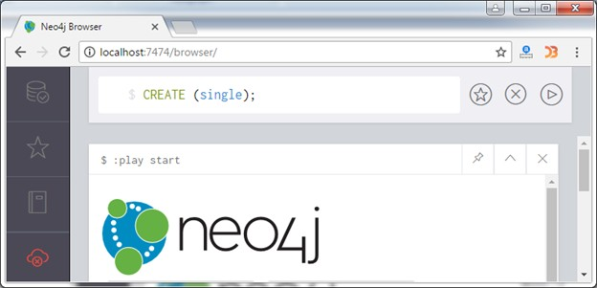

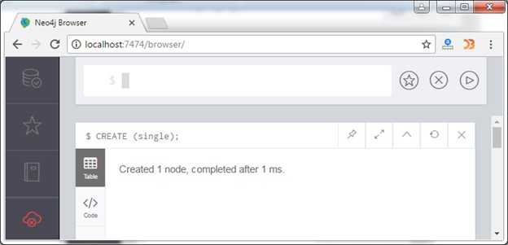

MATCH (n) RETURN (n)

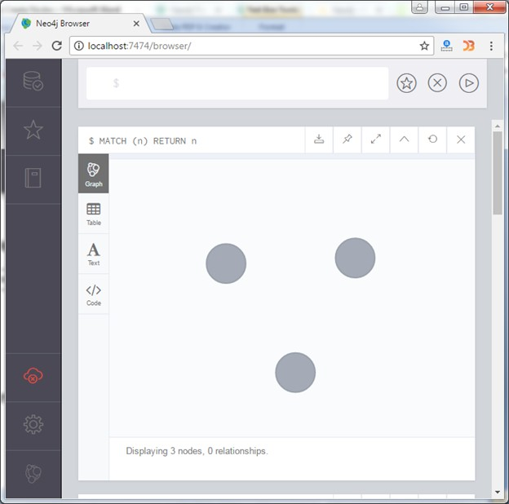

CREATE (primary_node), ( secondary_node);

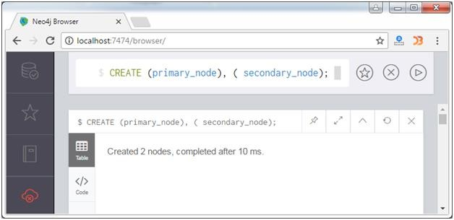

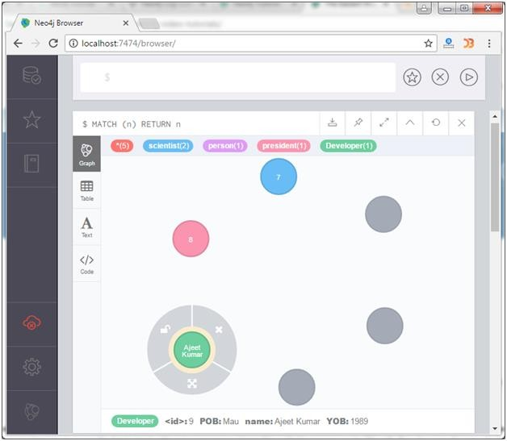

**RESULT:**

Thus the NoSQL database tool successfully designed and executed.

**DATABASE GUI APLLICATION – PAYROLL MANAGEMENT**

# EX.NO.12

**AIM:**

To design a staff payroll management System using VB with mysql as backend.

# SAMPLE CODE:

Dim db As

Database Dim rs As Recordset

Private Sub

cmdADD_Click()

rs.AddNew DtPicker

DOJ.Enabled = True

txtEmpID.Enabled = True

txtFirstName.Enabled = True

txtLastName.Enabled = True

txtAddress.Enabled = True

txtDOJ.Enabled = True

txtSalary.Enabled = True

txtEmpID.SetFocus

txtEmpID.Text = ""

txtFirstName.Text = ""

txtLastName.Text = ""

txtAddress.Text = ""

txtDOJ.Text=Date txtSalary.Text =""

txtHRA.Text = "" txtDA.Text = "" txtTA.Text = "" txtPF.Text= "" txtGrossPay.Text = "" txtNetPay.Text = "" cmdEdit.Enabled=False

cmdSubmit.Enabled = False cmdCalculate.Enabled=

False End Sub

Private Sub cmdCalculate_Click()If txtSalary.Text = "" Then

MsgBox "SALARY FIELD IS EMPTY", vbCritical, "Employees project"txtSalary.SetFocus Else

txtHRA.Text = 0.15 * Val(txtSalary.Text) txtDA.Text = 0.17 * Val(txtSalary.Text) txtTA.Text = 0.13 * Val(txtSalary.Text) txtPF.Text = 0.05 * Val(txtSalary.Text)

txtGrossPay.Text = Val(txtHRA.Text) + Val(txtDA.Text) + Val(txtTA.Text) + Val(txtSalary.Text)txtNetPay.Text

= Val(txtGrossPay.Text) - Val(txtPF.Text)

cmdSubmit.Enabled = True cmdADD.Enabled = False

End If End Sub

Private Sub cmdDelete_Click()

Dim msgboxres As VbMsgBoxResult

If rs.RecordCount = 0 Or txtEmpID.Text = "" Then

MsgBox "No records to delete", vbCritical, "Employees Project"

Else

msgboxres = MsgBox("Do you really want to Delete?", vbCritical + vbOKCancel, "Confirmation")If msgboxres = vbOK Then

Cancel=False rs.Delete

MsgBox "RECORD DELETED", vbCritical, "Employees Project" ClearALL

Else

Cancel=True End If 'rs.MoveNext End If

End Sub

txtFirstName.Enabled = True

txtLastName.Enabled = True txtAddress.Enabled = True txtDOJ.Enabled = True txtSalary.Enabled= True rs("FIRSTNAME") txtFirstName.Textrs("LASTNAME") txtLastName.Text rs("ADDRESS") txtAddress.Text rs("DATEOFJOINING") = txtDOJ.Text

rs("SALARY") =txtSalary.Text rs("HRA") = txtHRA.Text rs("DA") = txtDA.Text rs("TA") = txtTA.Text

rs("PF") = txtPF.Text rs("GROSSPAY") =txtGrossPay.Textrs

rs("NETPAY") = txtNetPay.Text

End Sub Private Sub cmdExit_Click()

Dim msgboxres As VbMsgBoxResult

msgboxres = MsgBox("Do you want to really exit?", vbCritical + vbOKCancel, "Confirmation")If msgboxres = vbOK Then

Cancel=False End

Else

Cancel=True End If

End Sub

Private Sub cmdFirst_Click() rs.MoveFirst cmdPrev.Enabled = False cmdFirst.Enabled = False

cmdNext.Enabled = True cmdLast.Enabled = True cmdEdit.Enabled = True GetData

End Sub

Private Sub cmdLast_Click()

rs.MoveLast cmdFirst.Enabled = True

cmdPrev.Enabled = True

cmdNext.Enabled = False

cmdLast.Enabled = False

cmdEdit.Enabled = True

GetData

End Sub

# cmdEdit.Enabled = True

# cmdFirst.Enabled = True

# cmdPrev.Enabled=True

# rs.MoveNext

# If rs.EOF = True

# Then

# cmdNext.Enabled=False

# e cmdLast.Enabled = False

# MsgBox "LAST RECORD", vbInformation, "Employees Project" rs.MoveLast

# Else GetData

# End If

# End Sub

# Private Sub cmdPrev_Click() cmdEdit.Enabled = True

# cmdFirst.Enabled = True

# cmdNext.Enabled = True

# cmdLast.Enabled = True

# rs.MovePrevious

# If rs.BOF = True

# Then

# cmdFirst.Enabled = False

# cmdPrev.Enabled = False

# MsgBox "FIRST RECORD", vbInformation, "Employees Project"

rs.MoveFirst Else GetData

End If

GetData End Sub

Private Sub cmdReport_Click() DataReport1.Show

End Sub

Private Sub cmdSubmit_Click() On Error GoTo errhandler2 rs("EMPID")=txtEmpID.Text

rs("FIRSTNAME") = txtFirstName.Text

rs("LASTNAME") = txtLastName.Text

rs("ADDRESS") = txtAddress.Text rs("DATEOFJOINING") = txtDOJ.Text

rs("SALARY") = txtSalary.Text

rs("HRA") = txtHRA.Text

rs("DA") = txtDA.Text

rs("TA") = txtTA.Text

rs("PF") = txtPF.Text

rs("GROSSPAY") =txtGrossPay.Text

rs("NETPAY") =txtNetpay.Text

Private Sub txtAddress_Change() cmdSubmit.Enabled = True

End Sub

Private Sub txtDOJ_Change() cmdSubmit.Enabled = True End Sub

[Private Sub txtEmpID_Change() cmdSubmit.Enabled = True

End Sub

Private Sub txtEmpID_KeyPress(KeyAscii As Integer)If (KeyAscii < 48 Or KeyAscii > 57) Then

KeyAscii = 0

MsgBox "PLEASE ENTER ONLY NUMBERS", vbCritical, "Employees Project"End If End Sub

Private Sub txtFirstName_Change() cmdSubmit.Enabled = True

End Sub

Private Sub txtLastName_Change() cmdSubmit.Enabled = True

End Sub

Private Sub txtSalary_Change() If txtSalary.Text <> "" Then

Cmd Calculate.Enabled = True

End If

End Sub

Public Sub ClearALL() Dim ctrl As Control

For Each ctrl In Me.Controls

If TypeOf ctrl Is TextBox

Then

ctrl.Text = "" Next

End Sub

Public Sub GetData()

If rs.RecordCount <> 0

Then

txtEmpID.Text = rs("EMPID")

txtFirstName.Text = rs("FIRSTNAME")

txtLastName.Text = rs("LASTNAME")

txtAddress.Text = rs("ADDRESS")

txtDOJ.Text = rs("DATEOFJOINING")

txtSalary.Text = rs("SALARY")

txtHRA.Text = rs("HRA")

txtDA.Text = rs("DA")

txtTA.Text = rs("TA")

txtPF.Text=rs("PF")

txtGrossPay.Text = rs("GROSSPAY")

txtNetPay.Text = rs("NETPAY") txtEmpID.Enabled = False txtFirstName.Enabled = False txtLastName.Enabled = False txtAddress.Enabled = False txtDOJ.Enabled = False txtSalary.Enabled = False txtHRA.Enabled = False txtDA.Enabled= False

txtTA.Enabled = False txtPF.Enabled = False txtGrossPay.Enabled =False txtNetPay.Enabled = False cmdSubmit.Enabled = False cmdCalculate.Enabled=FalsDtPickerDOJ.Enabled=False Else

txtEmpID.Enabled = False

txtFirstName.Enabled = False

txtLastName.Enabled = False

txtAddress.Enabled = False

txtDOJ.Enabled = False

txtSalary.Enabled = False

txtHRA.Enabled = False

txtDA.Enabled = False txtTA.Enabled = False txtPF.Enabled = False

txtGrossPay.Enabled = False

txtNetPay.Enabled = False c

mdSubmit.Enabled = False

cmdCalculate.Enabled = False End If

End Sub

PrivateSubtxtSalary_KeyPress(KeyAsciiAs Integer)

If (KeyAscii < 48 Or KeyAscii > 57) Then

KeyAscii = 0

MsgBox "PLEASE ENTER ONLY NUMBERS", vbCritical, "Employees Project"End If End Sub

Public Sub DisableFields() txtEmpID.Enabled = False

txtFirstName.Enabled = False

txtLastName.Enabled = False

txtAddress.Enabled = False

txtDOJ.Enabled = False

txtSalary.Enabled = False

cmdADD.Enabled = True

cmdCalculate.Enabled = False

cmdSubmit.Enabled = False

**DATABASE IN MS ACCESS:**

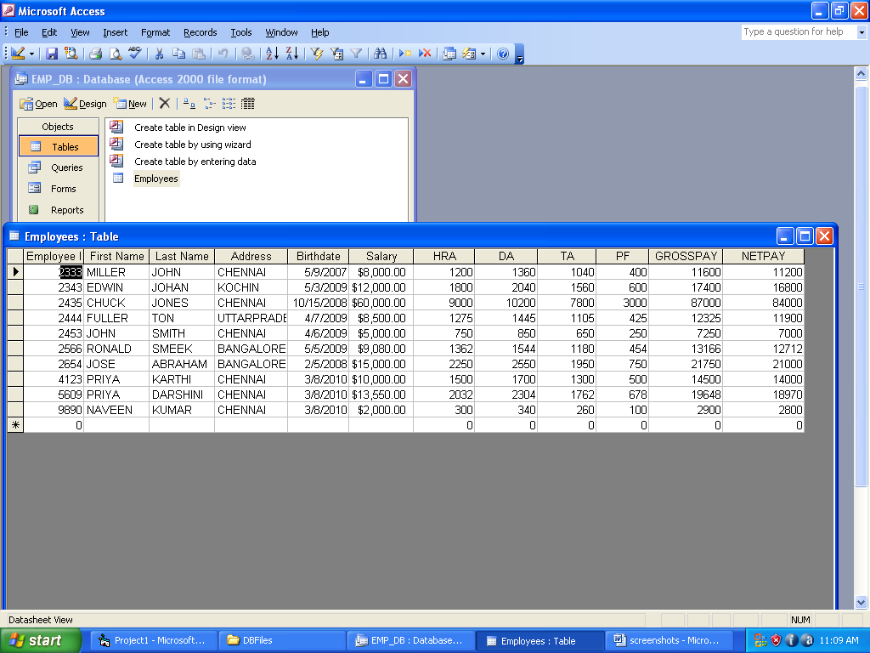

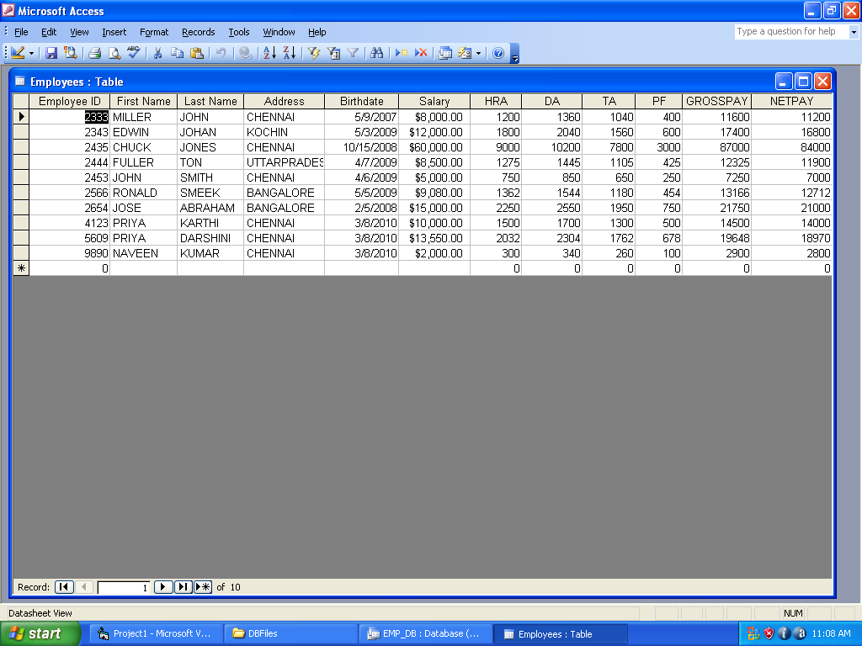

**FORMS WHILE EXECUTION:**

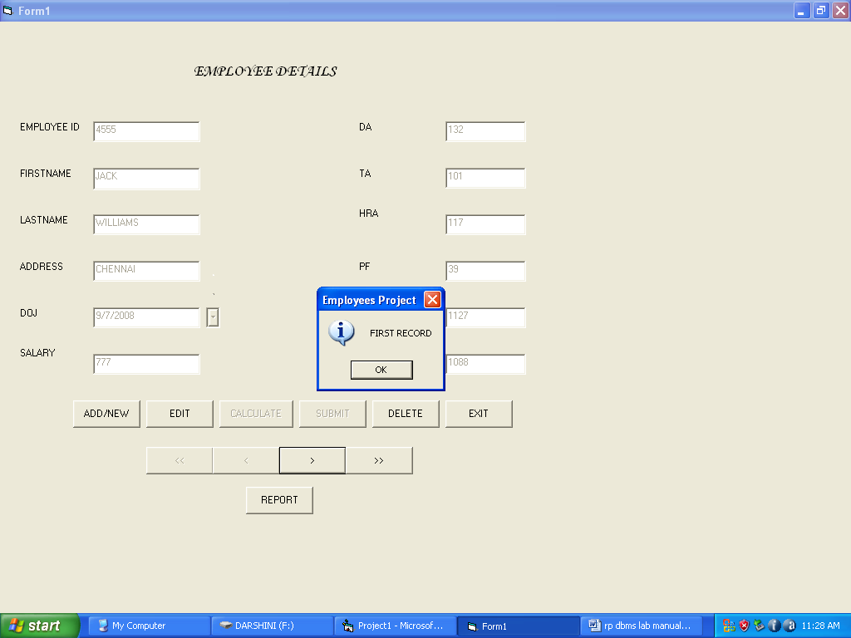

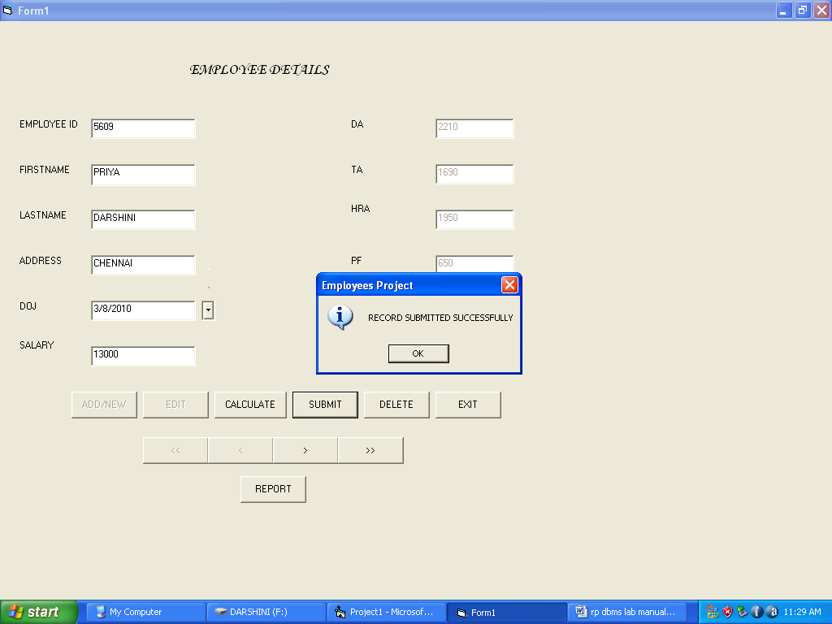

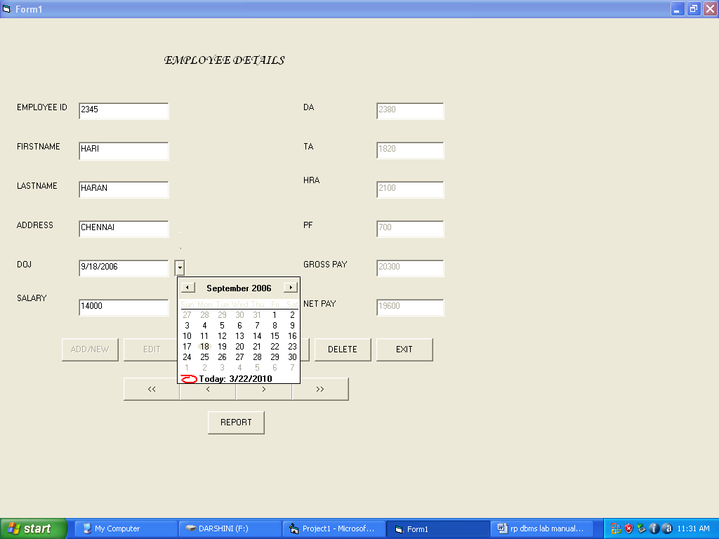

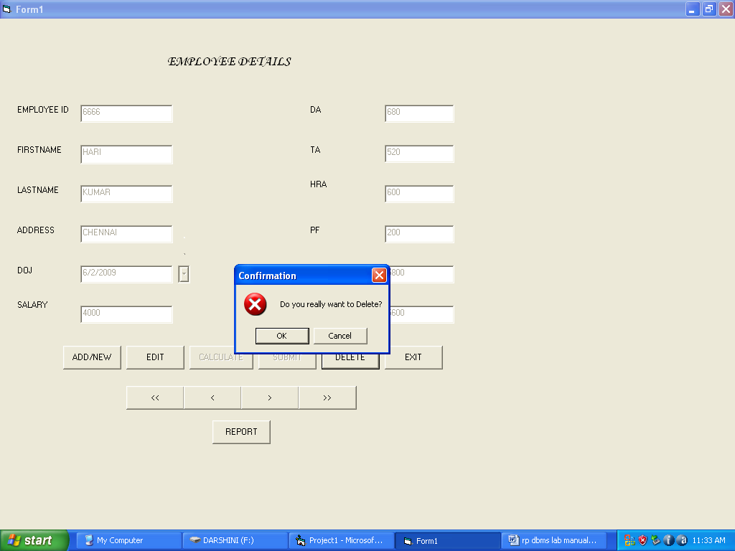

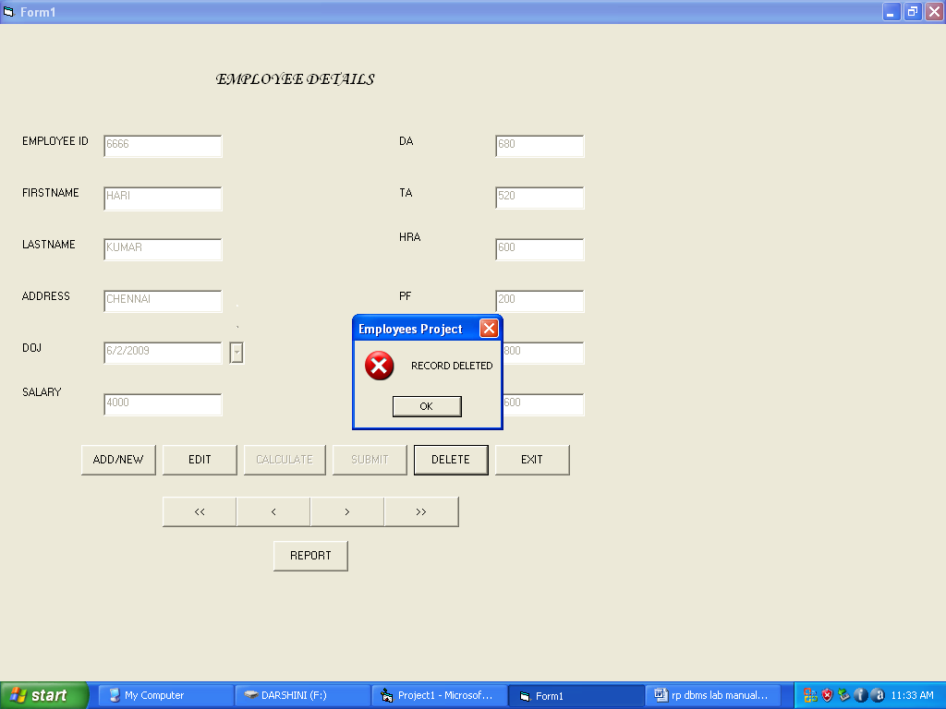

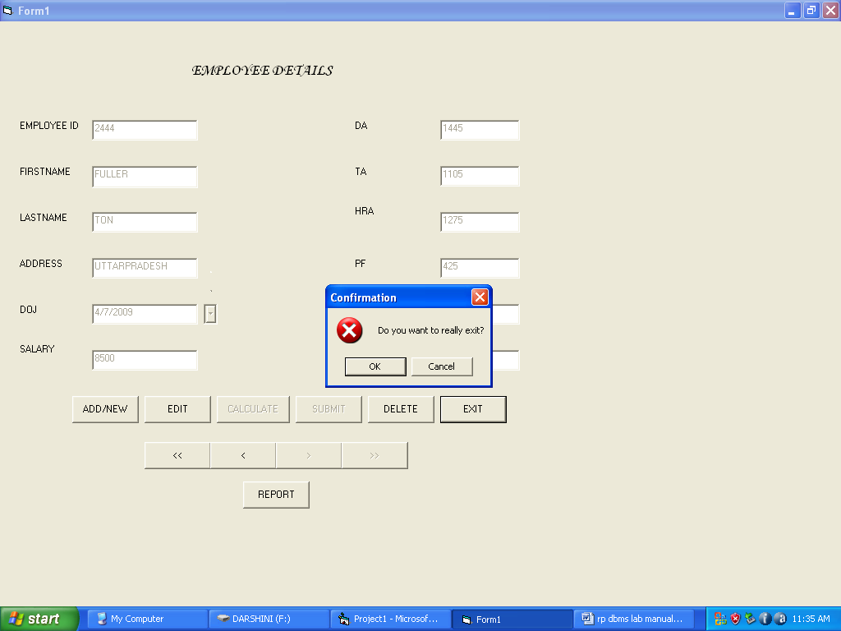

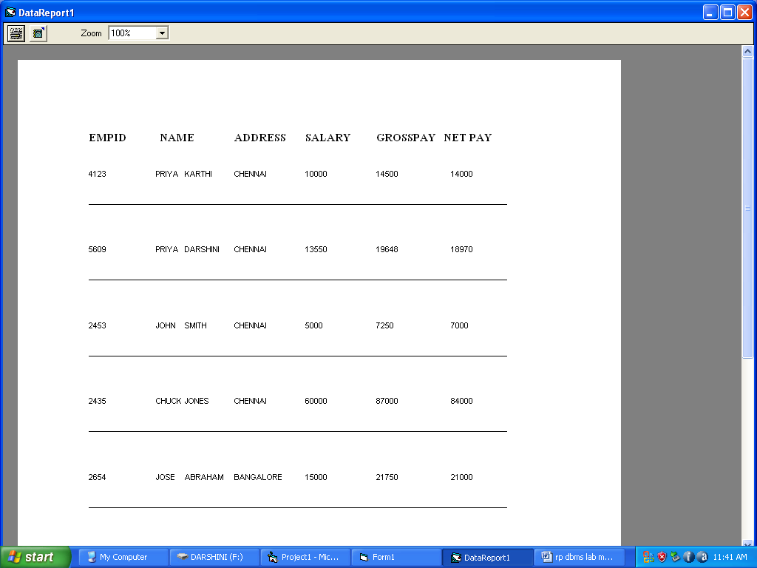

**RESULT:**

Thus the Student Personal Information System is successfully designed using PHPwith mysql as backend.

**CASE STUDY E-Mart GroceryShop**

**EX.NO:13**

**AIM:**

To create a database for E-mart Grocery shop and apply all sql properties.

# 

# SAMPLE CODE:

# SQL> create table grocery_visit(date TEXT, time_spent_min INTEGER, amount_spent REAL);

# SQL>create table grocery_list(date TEXT, item_name TEXT, item_category TEXT);

# insert into grocery_list values("2020-12-03", "Hamburger patties", "Meat and Fish");

# insert into grocery_list values("2020-12-03", "Chips", "Pantry");

insert into grocery_list values("2020-12-03", "Avocado", "Fruits and Vegetables");

insert into grocery_list values("2020-12-03", "Lime", "Fruits and Vegetables");

insert into grocery_list values("2020-12-03", "Tomato", "Fruits and Vegetables");

insert into grocery_list values("2020-12-15", "Rice cakes", "Pantry");

insert into grocery_list values("2020-12-15", "Graham crackers", "Pantry");

insert into grocery_list values("2020-12-15", "Toothpaste", NULL);

insert into grocery_list values("2020-12-15", "Flour", "Pantry");

insert into grocery_list values("2020-12-15", "Yeast", "Pantry");

insert into grocery_list values("2020-12-15", "Popcorn", "Pantry");

insert into grocery_list values("2020-12-15", "Eggs", NULL);

insert into grocery_list values("2020-12-15", "Milk", "Dairy");

insert into grocery_list values("2020-12-15", "Bananas", "Fruits and Vegetables");

insert into grocery_list values("2020-12-15", "Frozen waffles", NULL);

insert into grocery_list values("2020-12-23", "Mayo", "Pantry");

insert into grocery_list values("2020-12-23", "Flour", "Pantry");

insert into grocery_list values("2020-12-23", "Milk", "Dairy");

insert into grocery_list values("2020-12-23", "Roasted Chicken", "Meat and Fish");

insert into grocery_list values("2020-12-23", "Chocolate chip cookies", "Pantry");

insert into grocery_list values ("2020-12-23", "Yogurt", "Dairy");

insert into grocery_list values("2020-12-23","Soda",NULL);

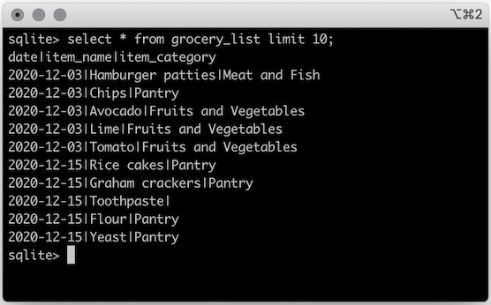

insert into grocery list values ("2020-12-23", "Grapes", "Fruits and Vegetables");

select * from grocery_list limit 10;

select * from grocery_list where item_category is null;

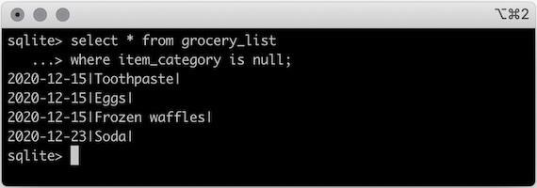

select distinct item_name from grocery_list;select distinct item_category from grocery_list;

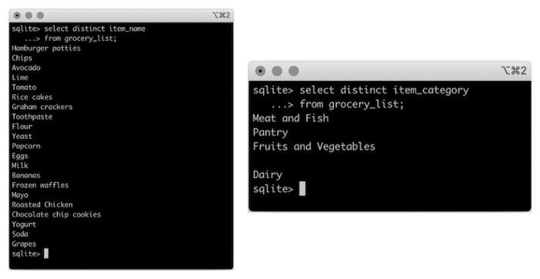

select *

from grocery_list

where item_category like 'Fruit%';

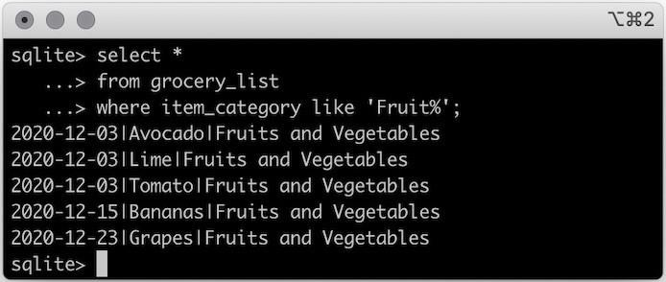

select * from grocery_visit where date between '2020-12-01' and '2020-12-15';

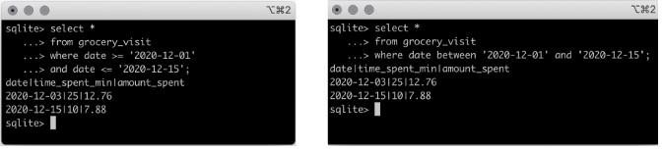

select count(*) as total_visits

, min(time_spent_min) as shortest_visit

, avg(time_spent_min) as average_visit

, max(time_spent_min) as longest_visit from grocery_visit;

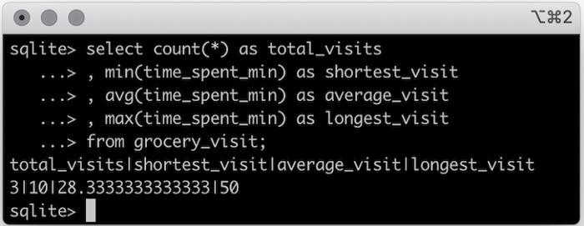

Cross join:

select *

from grocery_visit

cross join dept_store_visit

where grocery_visit.amount_spent > 15

and dept_store_visit.amount_spent > 15;

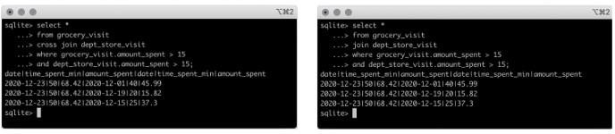

**RESULT:**

Thus the E-mart Grocery Shop is successfully designed.

1.[.What is DBMS and what is its utility? Explain RDBMS with examples.](https://www.interviewbit.com/dbms-interview-questions/#what-is-dbms-and-its-utility-explain-rdbms-with-examples)

[2.What is a Database?](https://www.interviewbit.com/dbms-interview-questions/#what-is-a-database)

[3.Mention the issues with traditional file-based systems that make DBMS a better choice?](https://www.interviewbit.com/dbms-interview-questions/#dbms-vs-file-system)

[4.Explain a few advantages of a DBMS.](https://www.interviewbit.com/dbms-interview-questions/#dbms-advantages)

[5.Explain different languages present in DBMS.](https://www.interviewbit.com/dbms-interview-questions/#dbms-languages)

[6.What is meant by ACID properties in DBMS?](https://www.interviewbit.com/dbms-interview-questions/#acid-properties-in-dbms)

[7.Are NULL values in a database the same as that of blank space or zero?](https://www.interviewbit.com/dbms-interview-questions/#are-null-values-same-as-blank-space-or-zero)

[8.What is Data Warehousing?](https://www.interviewbit.com/dbms-interview-questions/#what-is-data-warehousing)

[9.Explain different levels of data abstraction in a DBMS.](https://www.interviewbit.com/dbms-interview-questions/#levels-of-abstraction-in-dbms)

[10.What is meant by an entity-relationship (E-R) model? Explain the terms Entity, Entity Type, and Entity Set in DBMS.](https://www.interviewbit.com/dbms-interview-questions/#dbms-entity-relationship-model)

[11.Explain different types of relationships amongst tables in a DBMS.](https://www.interviewbit.com/dbms-interview-questions/#types-of-relationship-in-database-table)

[12.Explain the difference between intension and extension in a database.](https://www.interviewbit.com/dbms-interview-questions/#intension-vs-extension)

[13.Explain the difference between the DELETE and TRUNCATE command in a DBMS.](https://www.interviewbit.com/dbms-interview-questions/#delete-vs-truncate-dbms-commands)

[14.What is a lock. Explain the major difference between a shared lock and an exclusive lock during a transaction in a database.](https://www.interviewbit.com/dbms-interview-questions/#difference-between-dbms-shared-and-exclusive-lock)

[16.Explain different types of Normalization forms in a DBMS.](https://www.interviewbit.com/dbms-interview-questions/#normalization-in-dbms)

[17.Explain different types of keys in a database.](https://www.interviewbit.com/dbms-interview-questions/#dbms-keys)

[18.Explain the difference between a 2-tier and 3-tier architecture in a DBMS.](https://www.interviewbit.com/dbms-interview-questions/#difference-between-two-tier-and-three-tier-database-architecture)